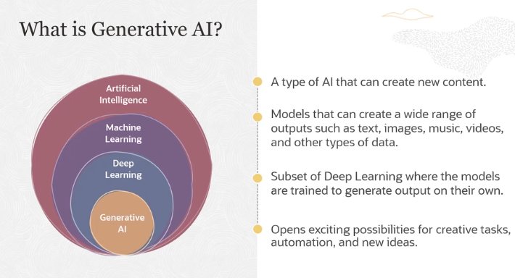

So what is AI? AI is the ability of machine learnings to imitate human intelligence. Machine learning is a subset of AI where algorithms are used to learn from past data, and predict outcome on new data, or to identify trends from the past data.

Deep learning is a further subset of machine learning in which algorithms are modeled to learn from complex data using neural networks. So we have looked at AI, machine learning, and deep learning in the previous modules. And in this module, we will look at generative AI in more details.

So as the name specifies, generative AI is a type of AI that can create new content. Generative AI includes models that can create a wide range of outputs such as text and any kind of media, whether it is images, music, videos, and other types of data. GenAI, as you can see from the graphic here, is a subset of deep learning where the models are trained to generate output on their own. And GenAI unlocks exciting possibilities for creative tasks, automation, and new ideas.

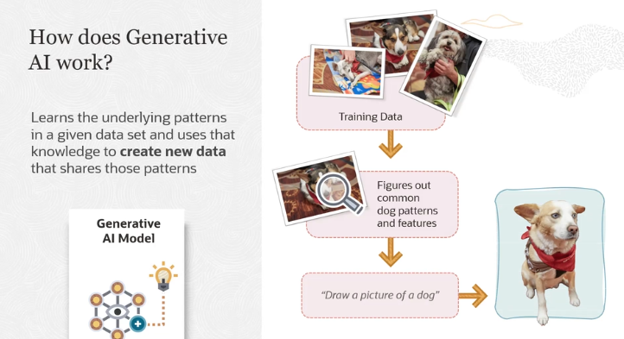

Generative AI is all about teaching a machine to create new content based on patterns it has learned from existing data. Here's a simple breakdown:

1. **Learning from Data**: Imagine you're teaching an AI to draw a dog. You start by giving it **lots of pictures of dogs**. The AI doesn't know what a dog looks like at first, but by analyzing these images, it starts to notice **common features** like pointy ears, sharp teeth, and whiskers.
2. **Understanding Patterns**: The AI is not memorizing individual pictures but rather **learning patterns** from all the images. It learns what typically makes up a "dog" by seeing many examples.
3. **Generating New Content**: After enough training, you can ask the AI to create a **new picture of a dog**. The AI uses the patterns it has learned to generate something new. It doesn't copy any picture it has seen before, but rather **creates a new image** that follows the patterns of what it has learned a dog looks like.
4. **Complex Math Behind the Scenes**: While this sounds straightforward, in reality, the process involves **a lot of math and computation**. There are various techniques and architectures that help the AI understand and generate data, but at the core, it's about learning patterns from data and generating new examples based on those patterns.

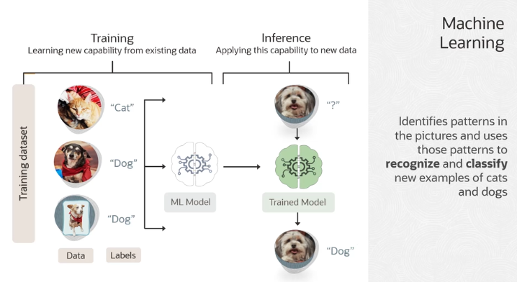

**How Machine Learning Works:**

1. **Training with Data and Labels**:
   * **Input Data**: We start by giving the machine learning (ML) model images of cats and dogs.
   * **Labels**: Along with each image, we also provide the label, like “Cat” or “Dog”. These labels help the model understand what it’s looking at.
   * For example, in the image, we show the ML model several pictures of cats and dogs, and with each picture, we provide the correct label.
2. **Feature Extraction**:
   * The ML model looks at each image and starts identifying patterns or **features**. These features might include things like body shape, fur texture, or ear shape.
   * It learns that certain patterns (e.g., whiskers, pointy ears) are linked with cats, while other patterns (e.g., floppy ears, short fur) are linked with dogs.
3. **Training the Model**:
   * As the model sees more and more examples, it **learns the relationship** between the input data (images) and the output labels (cat/dog).
   * This is the **training process**, where the model becomes more accurate in identifying whether an image is of a cat or a dog.
4. **Inference or Prediction**:
   * After the model has been trained, we now have a **trained model**.
   * In the **inference phase**, the model is given **new, unseen data** (like a new picture of a dog).
   * **Prediction**: The model then uses what it has learned to predict whether the new image is a dog or a cat. For example, in the image, we show it a new picture (without any label) and the model correctly predicts "Dog."

**Supervised Learning:**

* This entire process, where we provide both data (images) and their labels (cat/dog), is called **supervised learning**.
* The model is supervised or guided because we give it both the input and the correct answer during training.

**Difference from Generative AI:**

* In **machine learning**, we teach the model to **classify** or **recognize** things by learning patterns from labeled data.
* In contrast, **generative AI** creates **new** data (e.g., a new picture of a dog) based on patterns it learned, but without copying the original images.

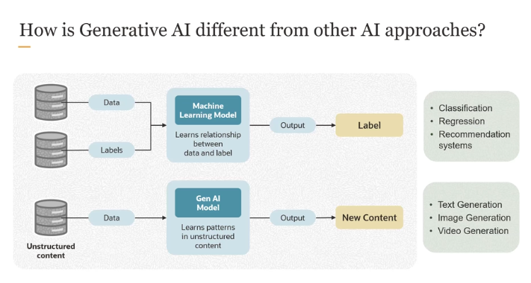

So in the case of a traditional machine learning model, the model learns relationship between data and label. And the output is a label, a prediction, or a classification. In the case of a GenAI model, the model is learning patterns in unstructured content. Unlike traditional machine learning, GenAI models don't require labeled data in its pre-training stage. It is pre-trained on unlabeled data.

Now, in later lessons, this is a more advanced topic. You will learn that a pre-trained GenAI model can be further trained on a labeled data set to obtain what we refer to as a fine-tuned model for specific tasks. But for the purposes of introducing you to generative AI, you can assume that the GenAI models are learning patterns based on unstructured content.

And the use cases are different. A traditional machine learning model can be used for classification. It could be used for making predictions, et cetera, while a GenAI model is used for generation. So it could be text generation, or it could be any kind of media generation.

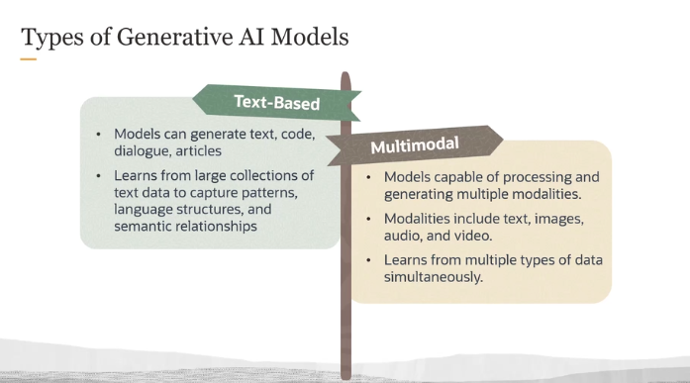

• **Text-based Generative AI**:  
These models focus on generating different forms of text. For example, they can create:

* **Text** (such as stories, articles, or essays)
* **Code** (programming scripts or functions)
* **Dialogues or Conversations** (like chatbots)
* These models are trained on vast amounts of text data, learning the patterns, structures, and meanings of language. Once trained, they can use that knowledge to generate new, coherent text that aligns with those learned patterns.

• **Multimodal Generative AI**:  
These models handle multiple types of data (or modalities) simultaneously, such as:

* **Text**
* **Images**
* **Audio**
* **Video**  
  These models are more versatile because they can process and generate content across different formats. For instance, they could generate a video from a text description or captions from an image. They learn by looking at data from multiple sources at once, understanding how these different forms are connected.

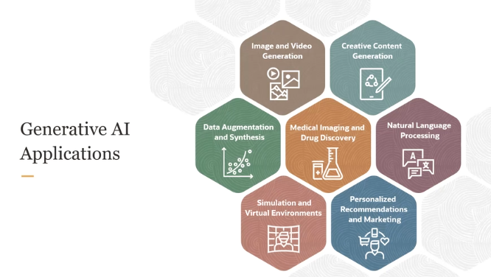

Generative AI is impacting a wide range of industries and use cases. Here are some key applications:

1. **Content Creation**:  
   Generative AI is used to create various forms of content, including:
   * **Text**: Writing articles, reports, stories, or even code.
   * **Creative content**: Generating art, music, and designs.
   * **Dialogue**: Powering chatbots and virtual assistants.
2. **Image and Video Generation**:  
   Generative AI can create realistic images and videos from scratch. This is used in entertainment, advertising, and social media for creating visuals and animations.
3. **Medical Imaging & Drug Discovery**:  
   In healthcare, Generative AI is transforming how we diagnose diseases and discover new drugs:
   * **Medical Imaging**: AI helps to analyze medical scans like MRIs or X-rays more accurately and quickly.
   * **Drug Discovery**: GenAI accelerates the development of new drugs by predicting the molecular structure of potential treatments, saving time in clinical research.
4. **Scientific Progress**:  
   Generative AI is boosting the rate of advancements in science, especially in fields like medicine. It helps researchers by offering new insights into data, improving diagnostics, and speeding up scientific experiments.